Input:

1 3 2 4 0 5 0 6 0 4 6

2 0 0 0 5 1 0 3 0 5 4

Output:

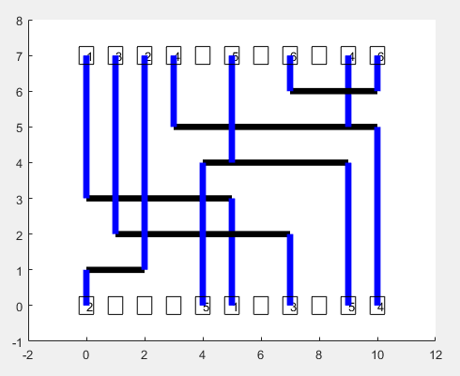

Input:

1 4 0 5 0 2 3 4

2 0 5 1 0 3 0 5

Output:

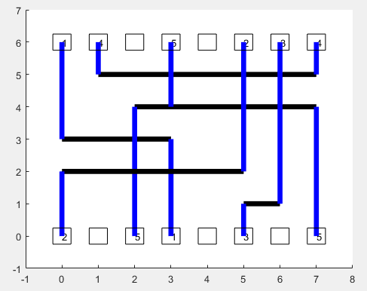

Input:

1 7 3 2 4 0 4 1 6 6 0 4 7 2 6

8 0 2 0 5 1 8 3 0 6 3 3 0 5 4

Output:

